Test Data

Below are the test results for Feedback Form & Contact Form.

* Feedback Form

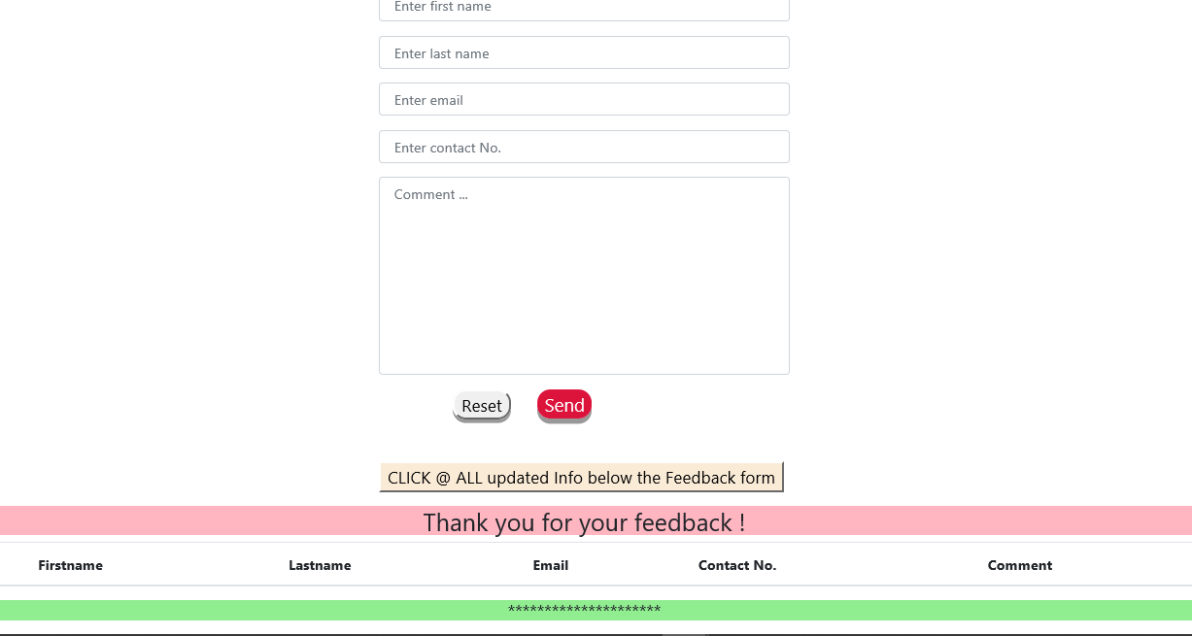

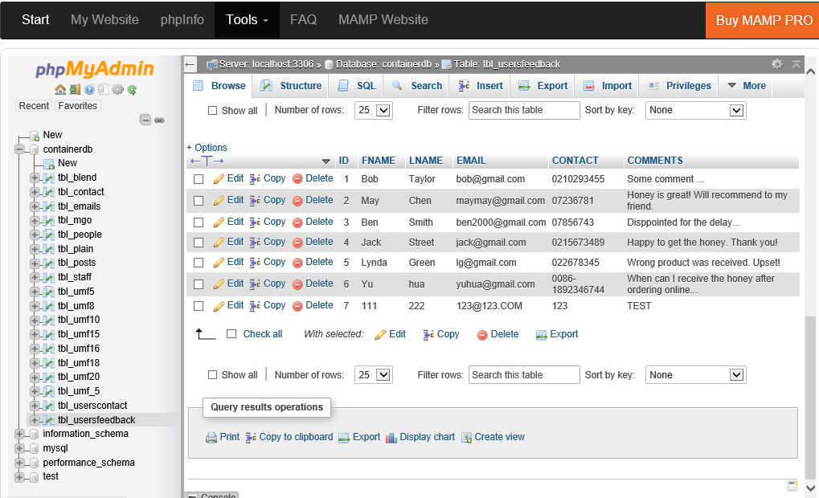

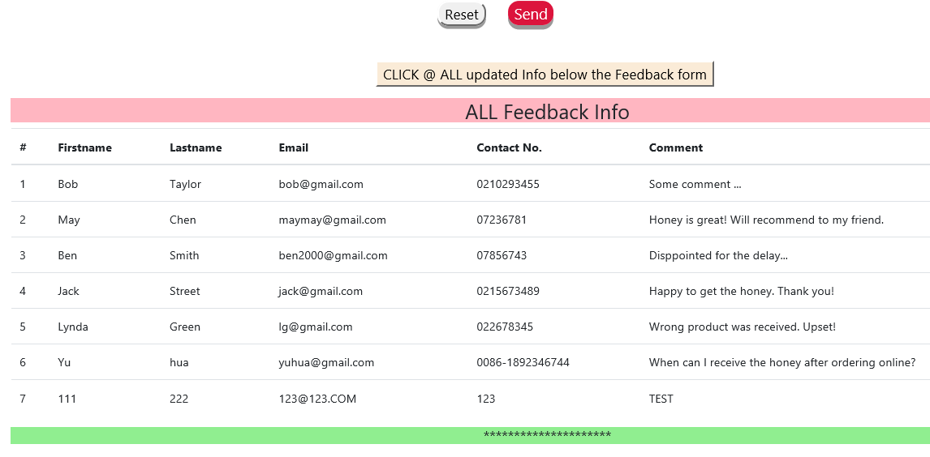

* Contact Form

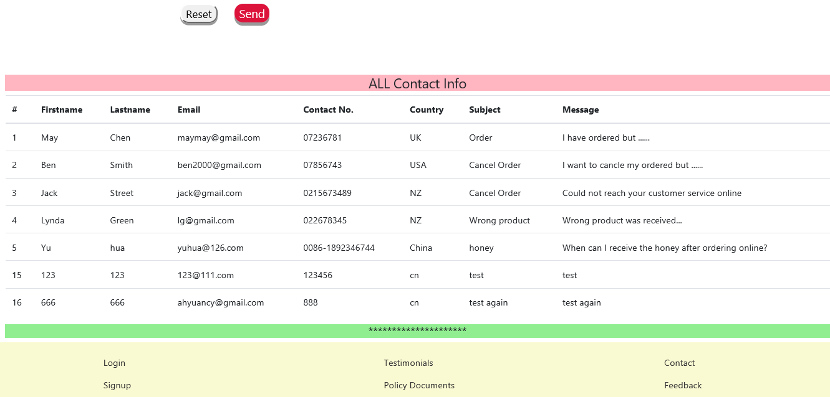

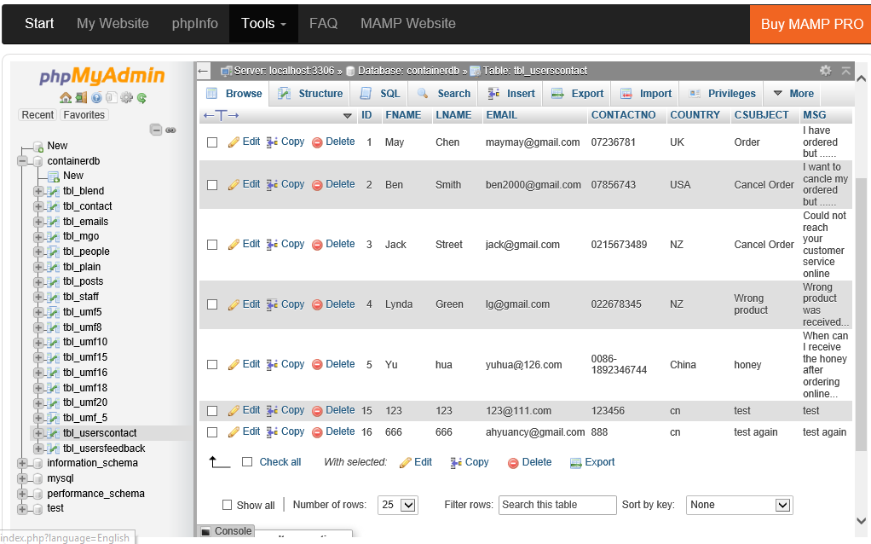

When the user’s email address was not found, an email will be sent out to notify me.

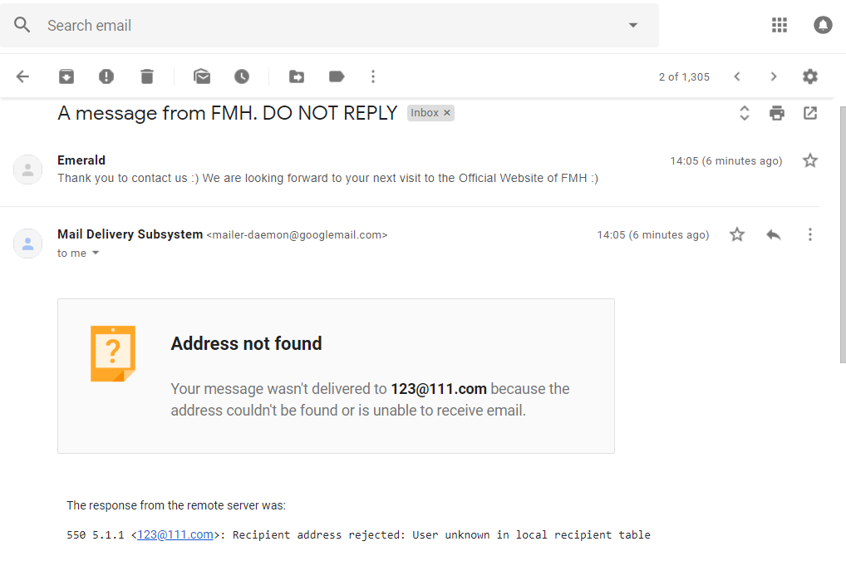

When the user submitted the contact info successfully, an email will be sent out to the user’s email address.

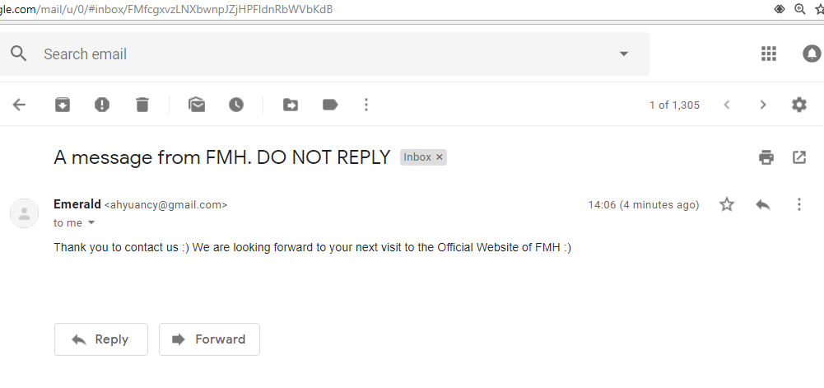

Tested: Marisa Wadsworth 26/10/2018

References

blend. [image].(2018).Retrieved from

<https://www.healthpost.co.nz/media/catalog/product/cache/1/image/9df78eab33525d08>d6e5fb8d27136e95/w/a/watson-and-son-new-zealand-manuka-blend-honey-wsmb-gv2_1.jpg

comvita_10. [image].(2018).Retrieved from

http:<//www.newzealandhoneyshop.co.uk/user/products/large/manuka-honey-umf10-500g.>jpg

comvita_10_500g.[image]. (n.d.).Retrieved from

https<://encrypted-tbn1.>gstatic.com/shopping?q=tbn:ANd9GcRkoaCGTxUffP7zOIjq33D8Yc7nzlaH4g1FwNLl3lydRVjO6_aiYG3uL7kR4h2aRveCDAU7WN5QDT9UPhAKSSrtOoOAKQVo3ij5Wif9DuVqnTfZsBFr7GUL&usqp=CAE

gohealth_5. [image].(n.d.).Retrieved from

<https://www.healthpost.co.nz/media/catalog/product/cache/1/image/9df78eab33525d08d6e5fb8d27136e95/g/o/go-healthy-go-manuka-honey-umf5-mgo80-gymk5-front_1.jpg>

mgo. [image].(2018).Retrieved from

<https://www.healthpost.co.nz/media/catalog/product/cache/1/image/9df78eab33525d08>d6e5fb8d27136e95/m/a/manukahealth-mgo-550_-manuka-honey-mk550-g_1_1.jpg

music_notes. [image].(n.d.).Retrieved from

http://img02.tooopen.com/images/20151123/tooopen_sy_149240426649.jpg

plain.[image].(2018).Retrieved from

https://shop.countdown.co.nz/Content/ProductImages/large/9414742002801.jpg/Signature-Range-Manuka-Honey.jpg

plain_2. [image].(2018).Retrieved from

https://www.luckyvitamin.com/images/Product/medium/161270_1.jpg

PureHoney. [image].(n.d.).Retrieved from

<https://5.imimg.com/data5/OX/VQ/MY-37032104/fresh-honey-500x500.jpg>

UMF_15_500g.[image]. (2018).Retrieved from

https://www.healthpost.co.nz/media/catalog/product/cache/1/thumbnail/130x/9df78eab33525d08d6e5fb8d27136e95/a/r/arataki-honey-manuka-honey-umf-15-atkm15g_3.jpg

umf_16_500g.[image].(2017).Retrieved from

https<://cdn.shopify.com/s/files/1/0338/3269/products/1Go-Healthy-Go-Manuka-Honey-Umf-1>6_-_Mgo-570_-500Gm.jpg?v=1528842282

UMF_16_1kg. [image].(2018).Retrieved from

<https://www.healthpost.co.nz/media/catalog/product/cache/1/image/9df78eab33525d08>d6e5fb8d27136e95/w/a/watson-and-son-new-zealand-manuka-honey-16-wsmh16-g_1.jpg

umf_18. [image].(2018).Retrieved from

<https://www.healthpost.co.nz/media/catalog/product/cache/1/image/9df78eab33525d08>d6e5fb8d27136e95/w/a/watson-and-son-new-zealand-manuka-honey-18-wsmh18-g_1.jpg

umf_20_250g.[image]. (2018).Retrieved from

https://d2kferpni7vbkj.cloudfront.net/media/catalog/product/cache/2/image/9df78eab33525d08d6e5fb8d27136e95/c/o/comvita-umf_20_manuka_honey_250g_2_1.png

umf20. [image].(2018).Retrieved from

<https://www.healthpost.co.nz/media/catalog/product/cache/1/image/9df78eab33525d08>d6e5fb8d27136e95/w/a/watson-and-son-new-zealand-manuka-honey-20-wsmh20s_1.jpg

WILDERNESS_8. [image].(n.d.).Retrieved from

http://www.wisecicada.co.nz/media/catalog/product/cache/1/image/300x300/9df78eab33525d08d6e5fb8d27136e95/w/i/wilderness-valley-manuka-honey-umf8_-250g.jpg